

MGM’s POLYTECHNIC, AURANGABAD
Micro Project Report
On
“ Working model of stair climber”

Submitted in partial fulfillment for ‘I’ Scheme second semester
2019-2020
Diploma in

MECHANICAL ENGINEERING

12157 MOHAMMED SAAD SAYYED (1915010276)
12158 SHAIKH ANAS AKBAR JALALUDDIN (1915010372)
12159 JADHAV VAIBHAV SAKHARCHAND (1915010381)
12160 KULKARNI KEYUR HRISHIKESH (1915010374)
12161 AGRAWAL GAURAV SANJAY (1915010382)

Under the guidance of
Prof. LOKAWAR V.L.


Maharashtra State
Board of Technical Education, Mumbai
(Autonomous) (ISO-9001-2008) (ISO/IEC 27001:2013)

CERTIFICATE
This is to certify Mohammed Saad Sayyed, Shaikh Anas Akhbar Jallaluddin, Jadhav Vaibhav Sakharchand, Kulkarni Keyur Hrishikesh, Agrawal Gaurav Sanjay . have successfully completed their micro Project work entitled “WORKING MODEL OF CONVEYOR BELT ” in partial fulfillment for ‘I’ Scheme second semester Diploma in Mechanical Engineering of Maharashtra State Board of Technical Education the matter embodied in this report is a record of their team work carried out during academic year 2019-20.

PROJECT GUIDE HOD

Prof. LOKAWAR V.L. Prof. PATIL S.S

Applied science Department Applied science Department

Principal
Dr. B. M. Patil

Micro-Project Proposal

“WORKING MODEL OF STAIR CLIMBER”

1.0 Brief Introduction
The main focus of this paper revolves around the providing a personal means of
negotiating stairs, the first question that must be considered is why are stairs used.

Stairs provide a means of ascent or descent. What alternatives are there to stairs? In terms of passive means slopes are the primary alternative. When considering powered assistive mechanisms such as escalators or lifts the range of alternatives is greater. The advantage of a slope (4.8 degrees max.

for manual wheelchair [1]) is that it does not significantly impede access to wheeled vehicles or most walking assistive devices. However the two inherent disadvantages of a slope are the space used compared to a set of stairs and the requirement that sufficient traction is present.

Firstly regarding space requirements. The conversion to, or addition of slopes (ramps) to
existing architecture is typically very costly and often negatively impacts the architecture with regard to functionality (waste space) and aesthetics. In the case of a multi-level building a ramp is usually not feasible.

For example a 4.8 degree ramp providing access between floors (typically
2.7m) would require 32.5 meters of ramp. Assuming a ramp width of 90cm this would require 29.5 square meters of floor area, excluding access, exit and turning areas. The space required by a standard (26cm tread, 18cm rise) stairway in the same situation would be 3.5 square meters, an 8.4 magnitude of spatial efficiency

2.0 Aim of the Micro-Project
- To easily climb the stairs.
- To reduce the effort.
- To make the human life more comfortable.

3.0 Action Plan

S. No. | Details of activity | Planned Start date | Planned Finish date | Name of Responsible Team Members
 | We search the information | 12/1/20 | 14/1/20 | Saad Sayyed
 | We make the model | 14/1/20 | 16/1/20 | Anas Shaikh ,
 | We make the report | 16/1/20 | 17/1/20 | saad, anas , Gaurav

4.0 Resources Required
S. No. | Name of Resource/material | Specifications | Qty | Remarks
 | DC motor | Rotating | 6
 | 9 watt battery | Power | 3
 | SCALE | Skeleton | 6

Micro-Project Report
“WORKING MODEL OF STAIR CLIMBER”

- Details of stair climber
The task of climbing stairs according to basic physics requires more energy than descent,
however the control in stair descent is more difficult. More energy is required climbing stairs but
because the stairs are sloping upwards they are easier to see, therefore easier to negotiate and the
risk of injury in the case of a fall is reduced on account of the reduced potential fall angle. The
fall angle/ height is assumed in the forward direction as this is the direction of travel, falling
rearward is less common, and is often associated with slipping on slippery surfaces.
The task of descending stairs represents effort in regard to control. The visual distance to
the stair is greater, therefore negotiation becomes more difficult. Stair descent is further
complicated by the higher risk of injury in event of a fall on account of the increased fall angle/
height.
The stair inherently represents greater risk of injury on account of the presence of a stair
edge combined with the potentially increased fall angle/ height. The worst case fall angle during
descent on a typical stair (35°) would be 125° (90°+35°) compared with 55° (90°-35°) for stair
ascent.

Following are the parts of the stair climber`

- WHEEL : The wheels of the vehical are the circular objects which are fixed underneath it and which enable it to move along ground.

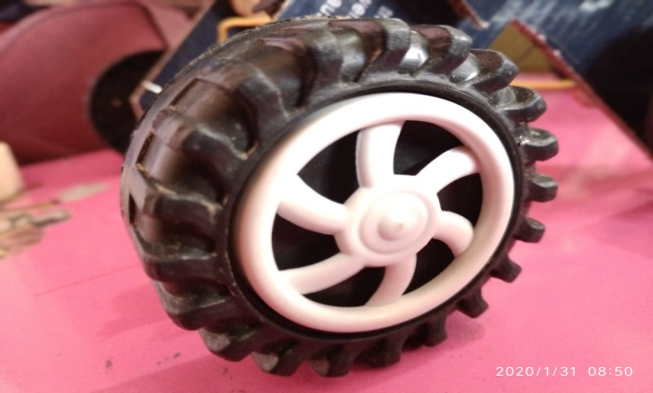
- AXEL : Axel is define as a central shaft for a rotating wheel or gear .

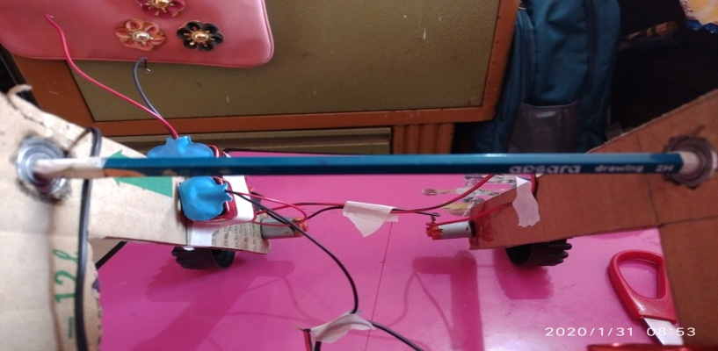
- BARINGS : Barings is use to view ,reveal or to bare ones arms .

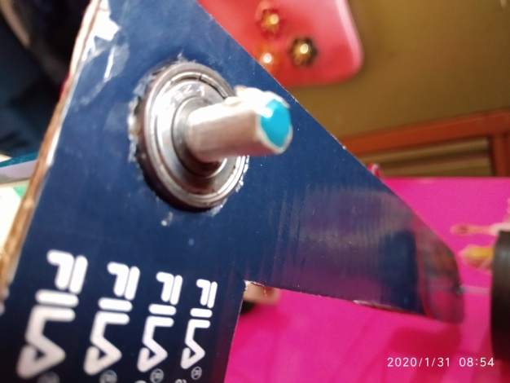
- MOTOR : Motor is any of a class of rotary electrical machines that convert direct current energy into mechanical energy.

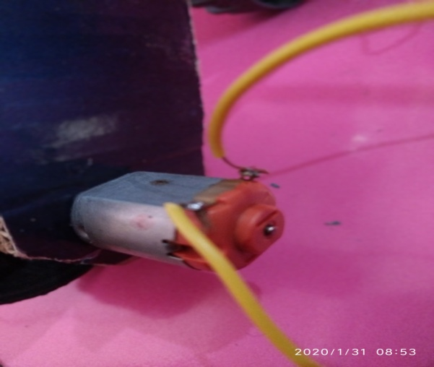
- BATTERY : Battery is use to to flows in a single direction and is generally used to power small appliances.
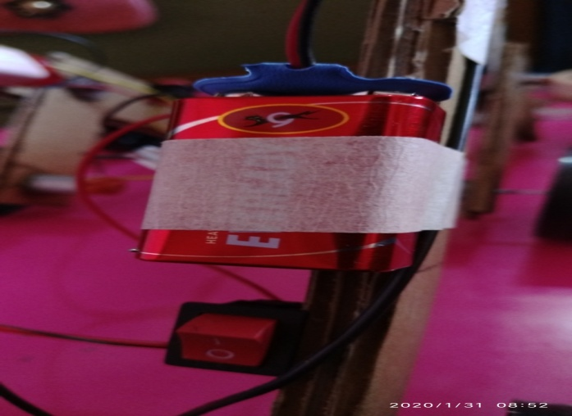
- SWITCH : Switch is use to on off purpose.

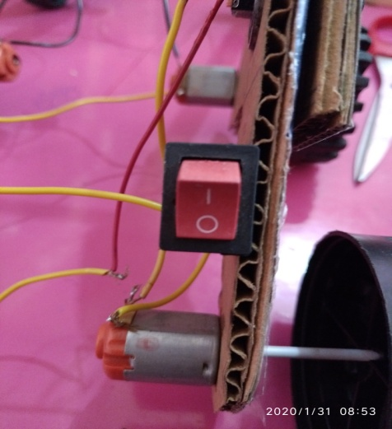
- ASSEMBLED MICRO PROJECT

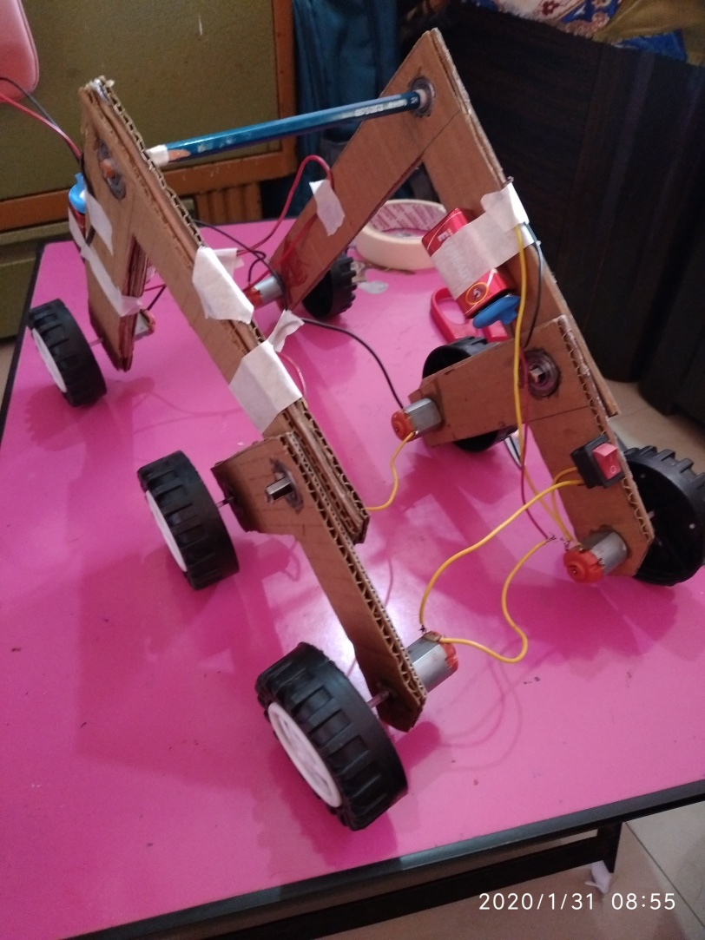

- Aim of Micro Project
- To reduce the load and use of workers
- Very fast and easy to transfer the products
- Use of technology is very good

- Course outcome Integrated
- Select the relevant simple lifting machines for engineering systems
- Determine unknown forces of different engineering systems

- Actual Procedure Followed.
- First we discus regarding the project with guide
- Then we finished the project
- We did literature survey on micro project
- We collected all the resources required for the micro project
- Then we assemble all parts together
- Then we suffer few problems during micro project
- Problems discussed with the guide and solved major problems occurred in the project
- Then we made a report on micro project
- At last we submitted towards our guide

5.0 Resources Required
S. No. | Name of Resource/material | Specifications | Qty | Remarks
1 | DC motor | Rotating | 6
2 | 9 watt battery | Power | 3
3 | sticks | Skeleton | 6

6.0 Actual Resources Used

S. No. | Name of Resource/material | Specifications | Qty | Remarks
 | DC motor | Rotating | 6
 | 9 watt battery | Power | 3
 | sticks | Skeleton | 6

7.0 Skill Developed / learning out of this Micro-Project
- We learned how to work in team
- We learned how to solve the problems which are occurred during making the project
- We learned how to assemble the parts
- We also learned of doing market survey
REFERENCES
- WWW.Machanics.com
- WWW.Science.com
- Engineering Machanics by Jain and Jain
- Engineering Machanics by S.S.Dara

